The divide and conquer technique is an algorithm design paradigm that solves complex problems by breaking them into smaller, manageable subproblems recursively (Divide), solving each subproblem (Conquer), and merging the solutions (Combine).
used in algorithms like Merge Sort, Quicksort, and Binary Search.
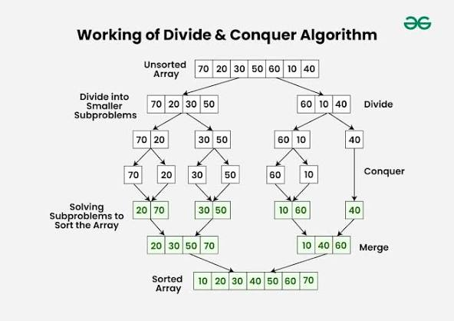
Recursion is the key mechanism here, enabling the algorithm to call itself on smaller inputs until a base case is reached

Pseudo Code:
ALGORITHM MergeSort(A, start, end)
IF start < end THEN
// Divide: Find the middle point
mid = floor((start + end) / 2)
// Conquer: Recursively sort the two halves
MergeSort(A, start, mid)
MergeSort(A, mid + 1, end)
// Combine: Merge the sorted halves
Merge(A, start, mid, end)
END IF
END ALGORITHM

